Mini Sentrix Hackathon – Day 1 Report
Team 5
Day 1 Theme
Foundation & Architecture
1. Objective
The objective of Day 1 was to establish the foundational infrastructure for a Mini Security Operations Center (SOC). The environment was designed to detect malicious activities, collect security logs, and visualize alerts within a Security Information and Event Management (SIEM) platform.
2. Environment Setup
A host-only virtual network was configured to enable secure communication between all virtual machines without external network dependency.
Network Configuration
Component | IP Address | Purpose
Kali Linux VM | 172.20.10.2 | Attack Simulation
Metasploitable2 VM | 192.20.10.5 | Vulnerable Target
Security VM | 192.20.10.7 | IDS and Log Collection
Ubuntu Host | 172.20.10.4 | SIEM Infrastructure

Connectivity Verification
The following tests were successfully performed:
- Kali Linux to Metasploitable2
- Kali Linux to Security VM
- Security VM to Wazuh Manager
All systems were reachable within the host-only network.

3. Architecture Diagram
Data Flow:
Kali Linux VM → Metasploitable2 → Suricata IDS → Wazuh Agent → Wazuh Manager → Elasticsearch → Kibana Dashboard
The architecture enables attack detection, log collection, alert correlation, and visualization through a centralized SIEM dashboard.

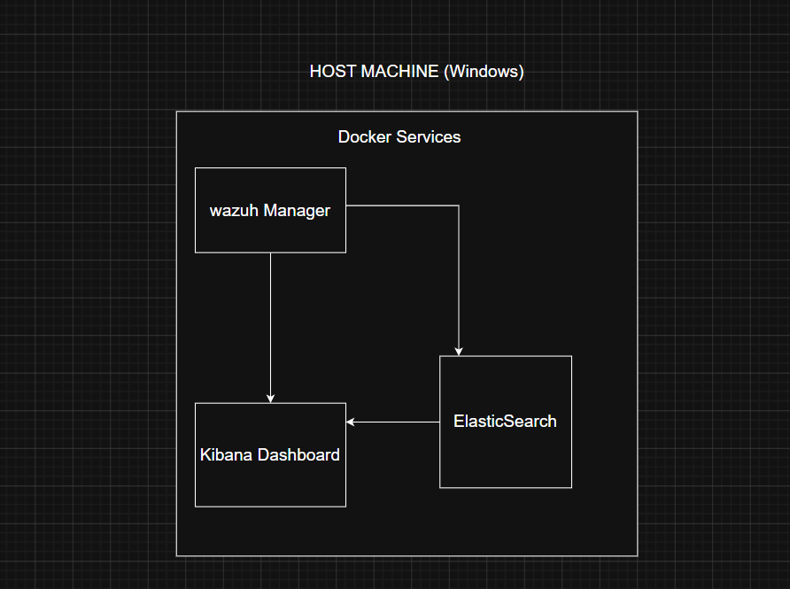

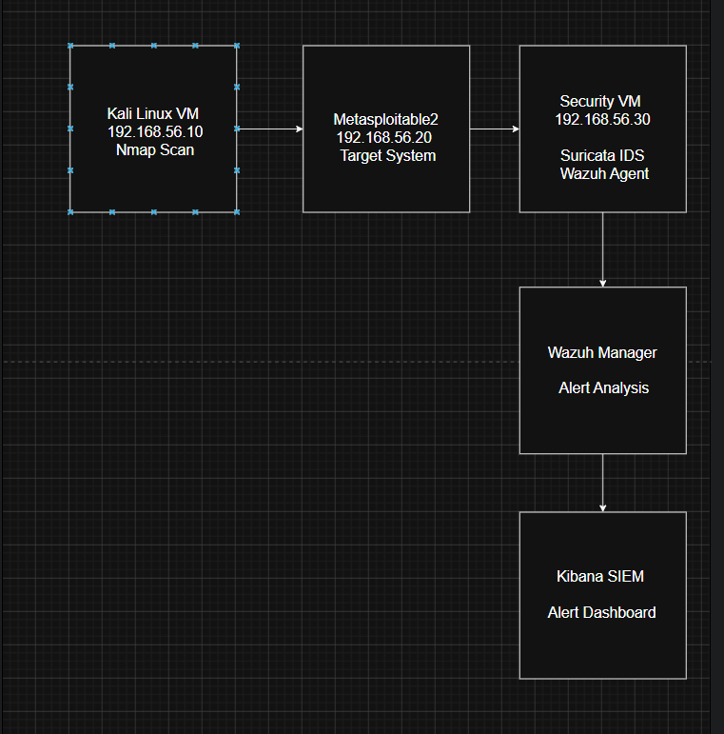

4. Tool Implementations
4.1 Suricata IDS
Purpose:
- Monitor network traffic
- Detect suspicious activities
- Generate security alerts

Reason for Selection:
- Open-source
- Lightweight
- Compatible with virtualized environments
4.2 Wazuh Agent
Purpose:
- Collect Suricata logs
- Forward security events to Wazuh Manager
Log Source:
- /var/log/suricata/eve.json
4.3 Wazuh Manager
Purpose:
- Centralized security event management
- Alert correlation and analysis
4.4 Elasticsearch
Purpose:
- Store and index security logs
- Enable efficient searching and querying
4.5 Kibana Dashboard
Purpose:
- Real-time visualization of alerts
- Security monitoring and analysis.

5. Alert Generation and Visibility in SIEM
Attack Simulation
The following command was executed from Kali Linux:
nmap -sS 192.168.56.20
This simulated a reconnaissance activity against the target machine.
Detection Process
- Kali Linux initiated an Nmap scan.
- Suricata detected scanning behaviour.
- Alert was generated in eve.json.
- Wazuh Agent collected the alert.
- Wazuh Manager processed the event.
- Elasticsearch stored the log.
- Kibana displayed the alert in the dashboard.

Sample Alert
Alert Name:
Potential Nmap Scan
Source IP:
192.168.56.10
Destination IP:
192.168.56.20
Severity:
Medium
Status:
Successfully displayed in SIEM Dashboard
6. Results
The Mini SOC environment was successfully deployed.
Achievements:
- Host-only network established
- All virtual machines communicating successfully
- Suricata IDS deployed and operational
- Wazuh SIEM infrastructure deployed
- Nmap attack detected successfully
- Alert visible in Kibana dashboard
- End-to-end log flow verified

7. Conclusion
Day 1 objectives were successfully completed. The team established a functional SOC foundation capable of detecting reconnaissance activities, collecting logs, and visualizing alerts within a centralized SIEM platform. This environment will be extended during subsequent phases to include WAF, IAM, and automated response capabilities.

